The World Bank data which consists of demographic data and other statistical data with various indicators ranging from Electricity/Power, Urban Population, Electricity, Energy Consumption and Agriculture for a few selected countries vis-a-vis climate change over a period of 1960 and 2020 . The data set being used are going to be targeting how some of these indicators are relevant to climate change. These indicators are each defined by code.

The following indicators have been chosen for analysis: **EG.USE.ELEC.KH.PC**-Electric power consumption (kWh per capita), **NV.AGR.TOTL.ZS**-Agriculture, forestry, and fishing, value added (% of GDP), **SP.URB.TOTL** -Urban population, **EN.ATM.CO2E.SF.KT**-CO2 emissions from solid fuel consumption (kt),**EG.ELC.NGAS.ZS**-Electricity production from natural gas sources (% of total).

The following countries have been chosen for analysis: **USA**-United States of America, **IND**-India, **CHN**-China, **JPN**-Japan, **CAN**-Canada, **GBR**-Great Britain, **ZAF**-South Africa.

This data set gotten from World Bank <https://data.worldbank.org/topic/climate-change>

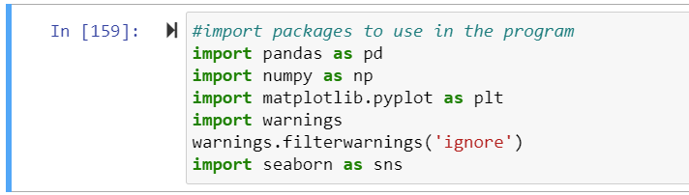



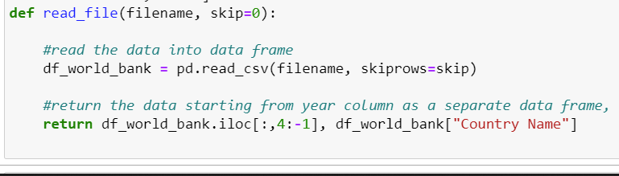

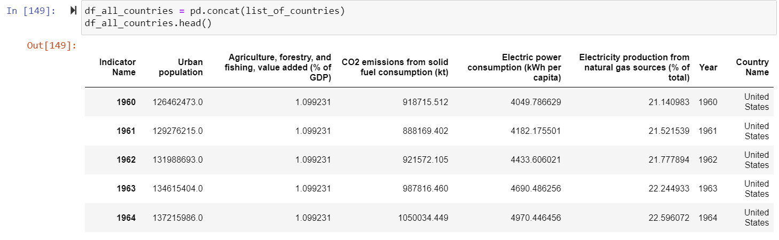

The images represens The first cell illustrates how we imported the dataset and printed the first five rows by calling the function head, and the second cell shows how we imported the dataset and printed the first five rows by calling the function head.

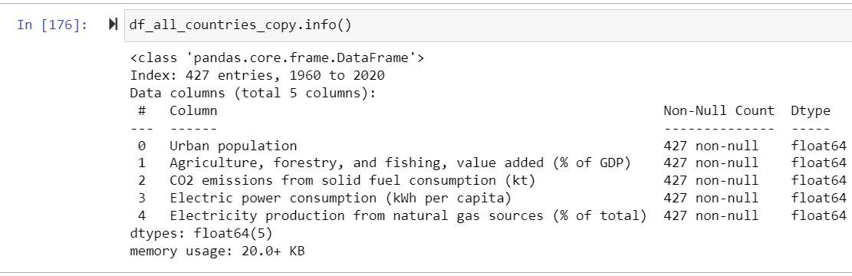

The graphic above depicts the dataset's information, summarizing the entire dataset's information by displaying the number of entries (row) of 827 and the number of columns of 3. It also reveals that there is one object, one int64, and one float datatype.

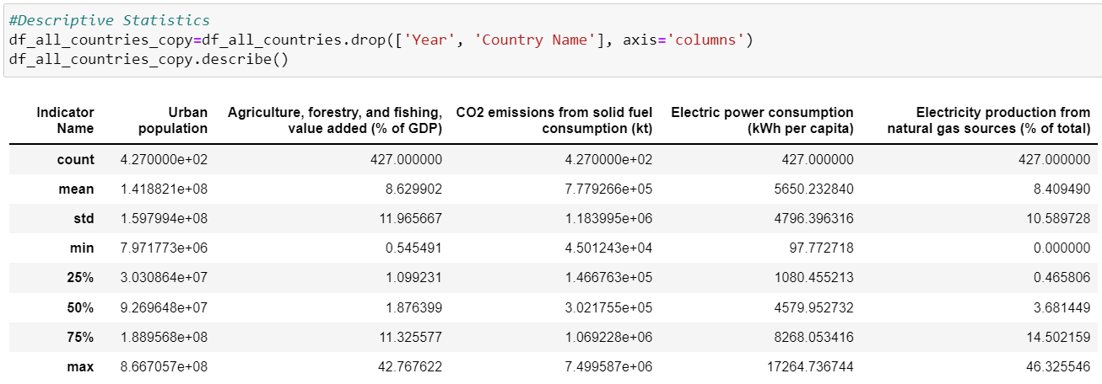

The figure above shows the statistical summary of the numerical columns on the dataset, telling us the count, mean, standard deviation, min max etc.

